Learning Chinese: Essentials
- Everyday Meeting
- Hello/Hi.
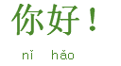
- Hello, everybody!
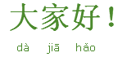
- Good morning!
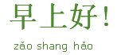
- Good afternoon!
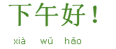
- Good evening!
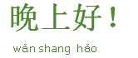
- Good night!
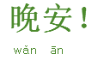
- First Meeting
- How do you do? Nice to meet you.
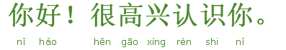
- How do you do? Glad to meet you.
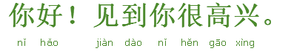
- Meeting after not seeing each other for some time
- Long time no see.
It's a long time since we met.
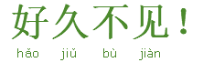
- How are you recently?
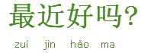
- I'm fine, thank you.
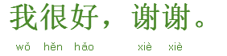
- Self-introduction
- My name is Jim.
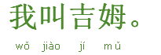
- I'm Jim.
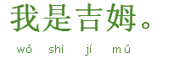
- I'm an American.
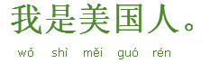
- I am a Canadian.
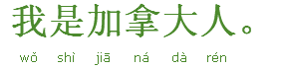
- I am an Australian.
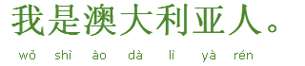
- I am a New Zealander.
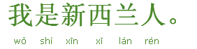
- Where are you from?
What is your nationality?
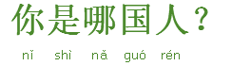
- I come from UK.
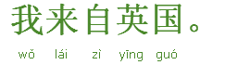
- I come from Ireland.
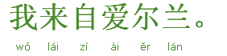
- I come from Philippines.
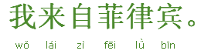
- I come from Japan.
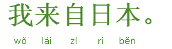
- I come from Malaysia.
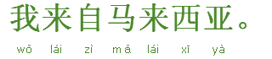
- Where do you come from?
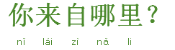
- Introducing people to each other
- This is Jim.
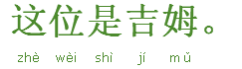
- He is Jim.
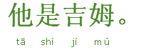
- She is Linda.
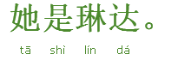

Expressing One's Thanks/Appreciation for other's Kindness
- Expressing one's thanks
- Thanks!
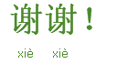
- Thank you!
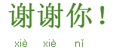
- Thanks/Thank you very much!
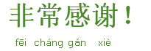
- Expressing appreciation for other's kindness
- Not at all.
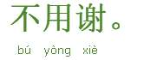
- You're welcome.
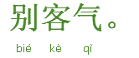

Farewell & Bidding Farewell
- Farewell
- Good bye/Bye bye/Bye!
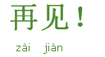
- See you.
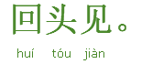
- See you tomorrow.
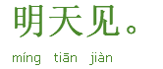
- So long.
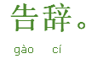
- Bidding Farewell - seeing a guest off
- Take care.
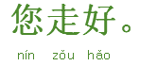
- Take care.
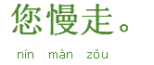
- I will not go any further.
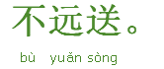
- Bidding Farewell-seeing off a friend on a long journey
- Take care.
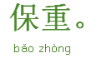
- Bon voyage!
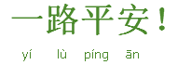
- Happy journey!
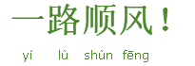

In a Trouble
- Could you do me a favour?
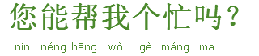
- Help!
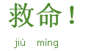
- Somebody helps me!
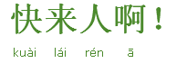
- Call the police.
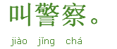
- Call 119 (for firemen).
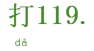
- Call 120 (for ambulance).
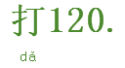
- Call 110 (for policemen).
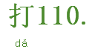
- My bag is stolen.
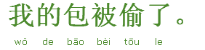
- My wallet is stolen.
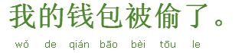
- My luggage is stolen.
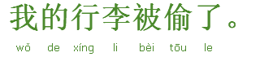
- I lost my passport.
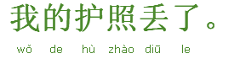
- I lost my key.
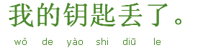

Good Wish & Congratulations
- Congratulations!
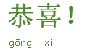
- May you be prosperous in the coming year!
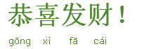
- Happy Chinese New Year!
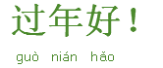
- Happy Chinese New Year!
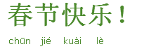
- Happy birthday to you!
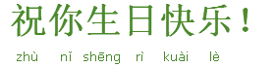
- Good Luck!
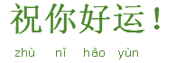
- Wish you success!
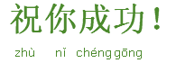
- Have a nice trip!
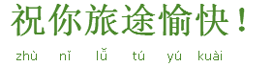

Apology & Forgiveness
- I'm sorry! Please forgive me!
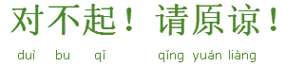
- I'm terribly sorry!
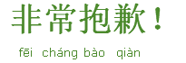
- I really feel bad about it!
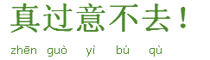
- It's my fault.
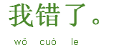
- Not at all.
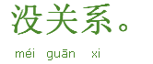
- Don't mention it.
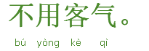
- It's OK/All right/Don't worry about it.
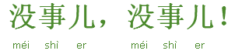

Asking about/Telling Price
- Asking about Price
- How much is it?
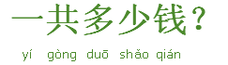
- How much is the apple?
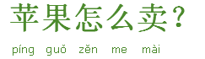
- How much is the pear?
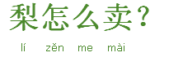
- How much are the oranges?
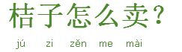
- How much are the grapes?
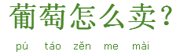
- How much is the cup?
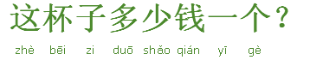
- How much is the bowl?
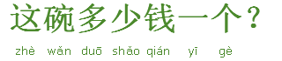
- How much is the vase?
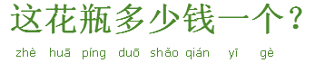
- Telling the price
- The apple is RMB5 per 0.5kg.
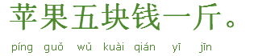
- The cup is RMB10 per one.
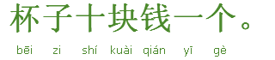

At a Restaurant
- Finding a Table
- Is there a place vacant?
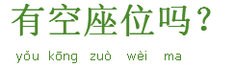
- How long is the wait?
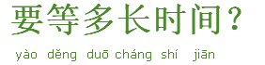
- A table for two.
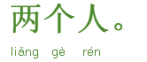
- We'd like to take a table by the window.
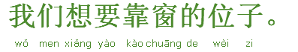
- I want a non-smoking seat, please.
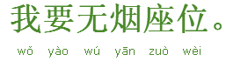
- May we sit here?
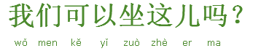
- I don't like this table. Can I have another one?
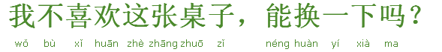
- We've reserved a table for four.
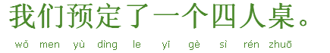
- Do you have a private room?
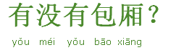
- Ordering Food
- What's your speciality?
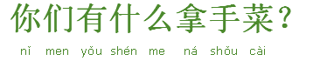
- How's your roast duck?
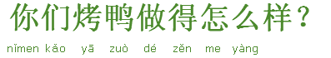
- How's your dumpling?
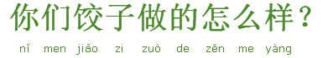
- How's your wonton?
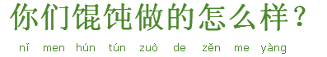
- Do you have a set menu?
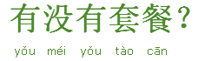
- Can you recommend some dishes?
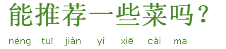
- I'll have Kung Pao Chicken and Tomato and Egg Soup.
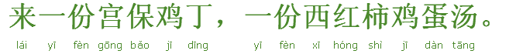
- I'll have Ma Po Tofu and Sweet and Sour Pork Fillet.
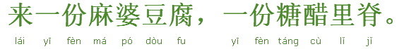
- Do you have any beer?
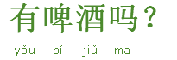
- May I have some water, please?
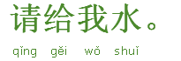
- Go easy on the pepper.
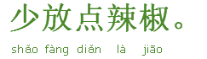
- Go easy on the salt.
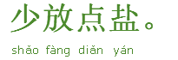
- Go easy on the vinegar.
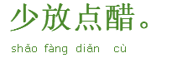
- I don't eat spicy food.
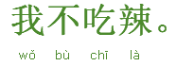
- I don't eat gourmet powder.
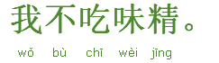
- I don't eat sugar.
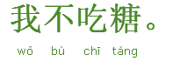
- I'll take rice first.
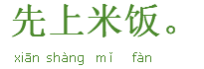
- I'll take soup first.
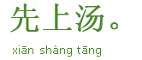
- I'll take my dishes first.
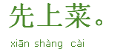
- I'll take dessert first.
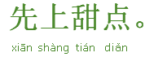
- Bring me the rice along with the dishes, please.
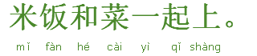
- My order hasn't come yet.
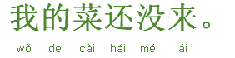
- How do you eat this?
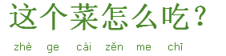
- I didn't order this dish.
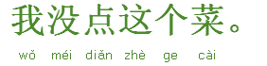
- This dish is undercooked.
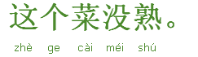
- Another cup of water, please.
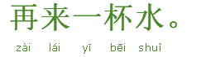
- Could you bring me a plate, please?
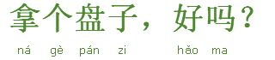
- Could you bring me a folk and a knife, please?
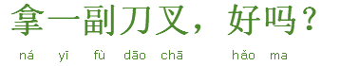
- Paying the Bill
- Waiter/waitress, bill please.
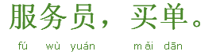
- May I have a doggy bag please?
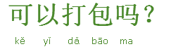
- May I have a look at the bill?
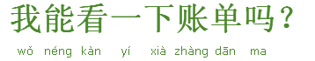
- May I have a look at the menu?
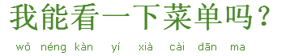
- May I have a receipt?
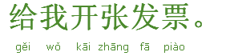

On a City Bus/Subway
- Inquiring
- Excuse me, I want to go to the Badaling Great Wall.
At which stop shall I get off?
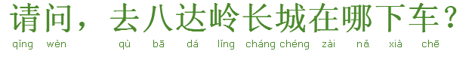
- Excuse me, I want to go to the Tiananmen Square.
At which stop shall I get off?
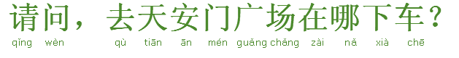
- Excuse me, I want to go to the Forbidden City.
At which stop shall I get off?
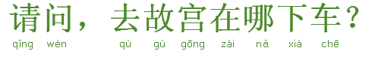
- Excuse me, what’s the next stop?
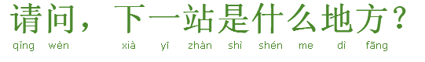
- Excuse me, how many stops are there from here to the Summer Palace?
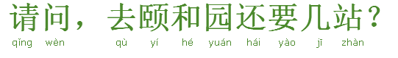
- Excuse me, how many stops are there from here to the Temple of Heaven?
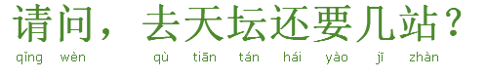
- Excuse me, how many stops are there from here to the Bird's Nest?
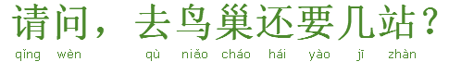
- Excuse me, what’s the nearest stop to the Bund?
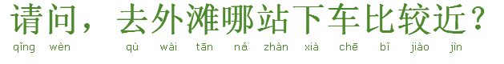
- Excuse me, what’s the nearest stop to Nanjing Road?
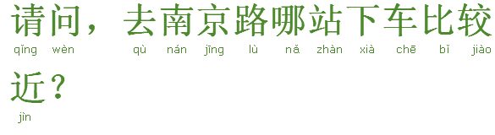
- Excuse me, what’s the nearest stop to the Oriental Pearl
TV Tower?
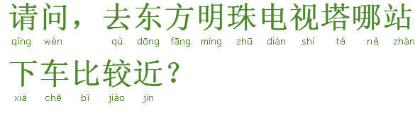
- Excuse me, could you tell me how to get to the Jade Buddha Temple after
getting off the bus?
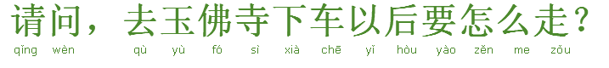
- Excuse me, could you tell me how to get to the Yuyuan Garden after
getting off the bus?
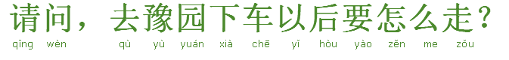
- Excuse me, could you tell me how to get to the Shanghai Museum after
getting off the bus?
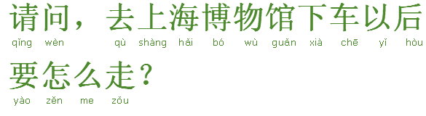
- Excuse me, do I need to change a bus to the Terra Cotta Worries?
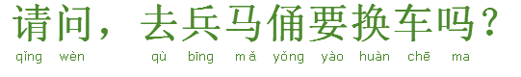
- Excuse me, do I need to change a bus to the Bell Tower?
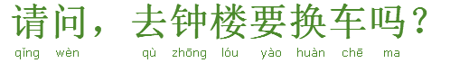
- Excuse me, do I need to change a bus to the Drum Tower?
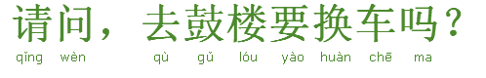
- Excuse me, which bus shall I change to the City Wall?
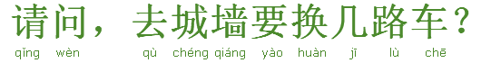
- Excuse me, which bus shall I change to the Big Wild Goose Pagoda?
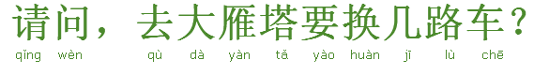
- Excuse me, which bus shall I change to the Shaanxi Provincial
History Museum?
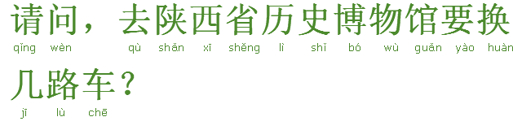
- Buying a ticket
- One ticket to the Humble Administrator's Garden, please.
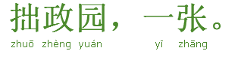
- One ticket to the Garden of the Master of the Nets, please.
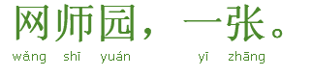
- One ticket to the Tiger Hill, please.
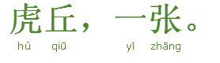
- How much is it to the Dr. Sun Yat-sen's Mausoleum?
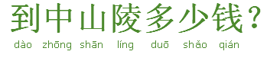
- How much is it to the Confucius Temple?
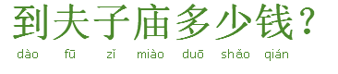
- How much is it to the Qinhuai River?
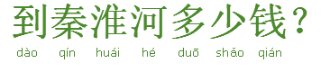

On a Taxi
- Telling the destination
- Pudong Airport, please.
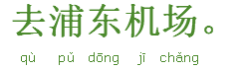
- Hongqiao Airport, please.
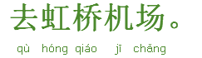
- Capital Airport, please.
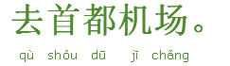
- Take me to this place, please.
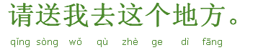
- Asking for information
- How much is it to South Railway Station?
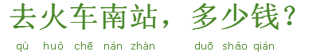
- How much is it to North Railway Station?
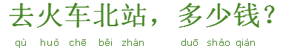
- How much is it to West Railway Station?
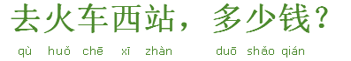
- How much is it to East Railway Station?
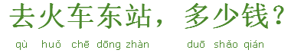
- How long does it take to the South Long-distance Bus Station?
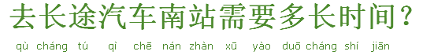
- How long does it take to the pier?
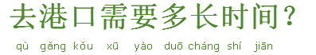
- How long does it take to the nearest subway Station?
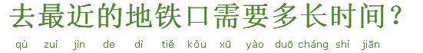
- Giving a suggestion
- Excuse me, could you please drive a bit faster? I'm in a hurry.
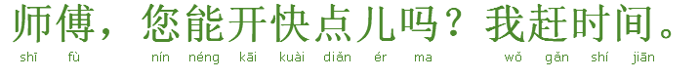
- Excuse me, could you please drive more slowly? I feel dizzy.
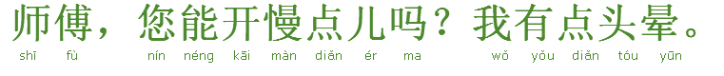
- Could you wait here for a minute?
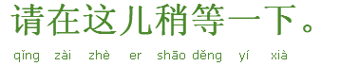
- Please drop me off in front of the tall building ahead.
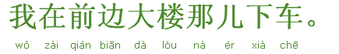
- Please drop me off in front of the bus station ahead.
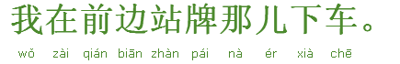
- Please drop me off in front of the doorway of the shop ahead.
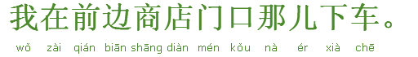
- Let me off here.
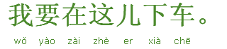
- Stop the car.
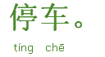
- Driver, please use the fee register.
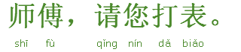
- We are held in a traffic jam. Could we take another road to get there?
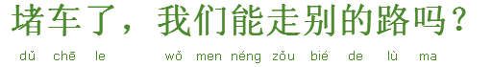

At the Railway Station
- Inquiring
- Excuse me, where is the ticket office?
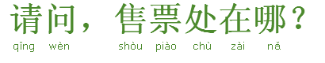
- Excuse me, where is the information desk?
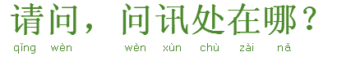
- Excuse me, where is the smoking room?
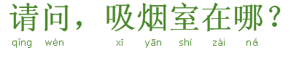
- Excuse me, where can I return the ticket?
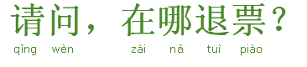
- Excuse me, where can I store the luggage?
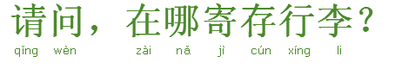
- Excuse me, where can I change some RMB?
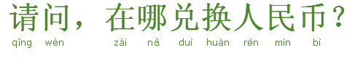
- Excuse me, could you tell me which trains go to Shanghai?
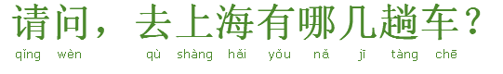
- Excuse me, could you tell me which trains go to Beijing?
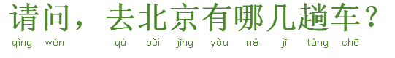
- Excuse me, could you tell me which trains go to Tianjin?
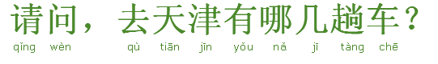
- Excuse me, when will the next train to Xian leave?
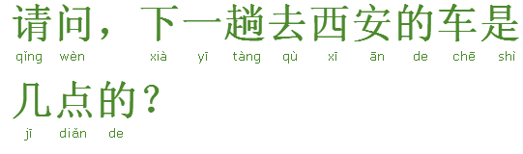
- Excuse me, when will the next train to Guilin leave?
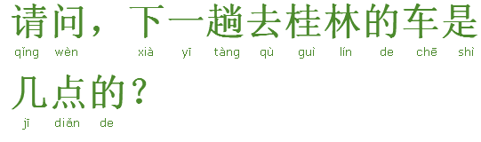
- Excuse me, when will the next train to Guangzhou leave?
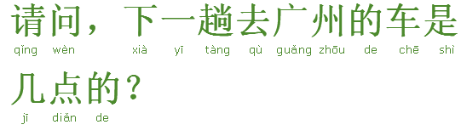
- Excuse me, when will the next train to Shenzhen leave?
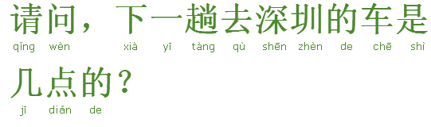
- Excuse me, at which platform is train G11?
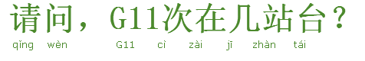
- For how long is train G11 late?
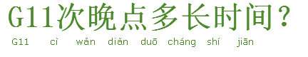
- How long will it take for train G11 to get to Shanghai?
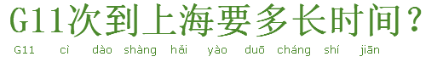
- Buying a Ticket
- A first-class ticket on train G12 on 8th.
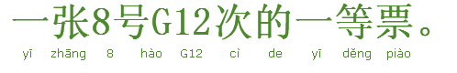
- A second-class ticket on train G12 on 8th.
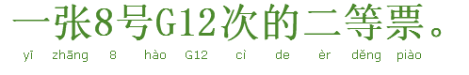
- A ticket for soft sleeper to Kunming at tomorrow night.
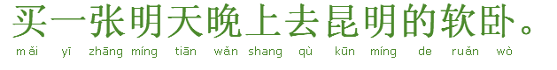
- A ticket for hard sleeper to Kunming at tomorrow night.
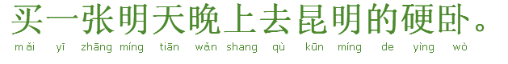
- A ticket for soft seat to Kunming at tomorrow night.
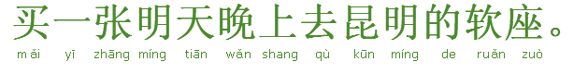
- A ticket for hard seat to Kunming at tomorrow night.
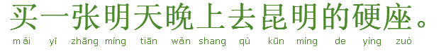
- I’d like a ticket for the lower berth.
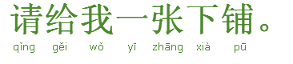
- I’d like a ticket for the middle berth.
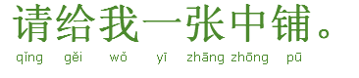
- I’d like a ticket for the upper berth.
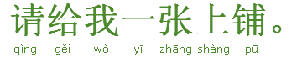
- Can I have a return ticket from Shenzhen?
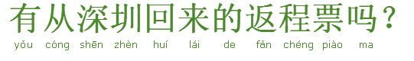
- Getting on the train
- Where is the carriage 10?
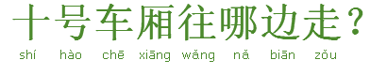
- Which carriage is the dinner carriage?
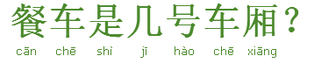

At the Airport
- Buying a Ticket
- I’d like a ticket for the economy class to Hangzhou.
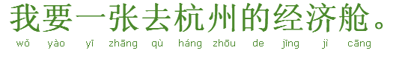
- I’d like a ticket for the business class to Hangzhou.
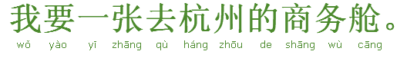
- I’d like a ticket for the first class to Hangzhou.
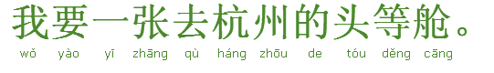
- I’d like a window seat.
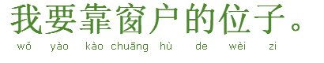
- I’d like an aisle seat.
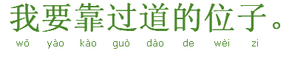
- Are the round-way tickets available?
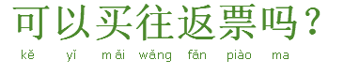
- Are the single-trip tickets available?
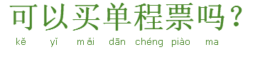
- Checking in
- My air ticket and passport.
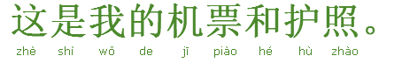
- I’d like to have my luggage checked.
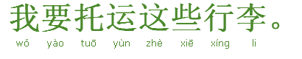
- At the Customs
- I have nothing to declare.
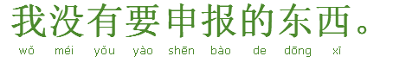
- Are these articles to be declared?
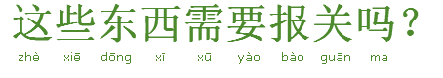
- These are my carry-on articles.
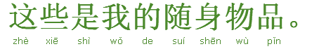
- The computer is for my own use.
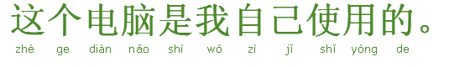
- The cellphone is for my own use.
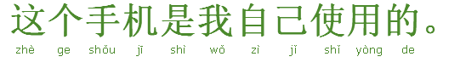
- This is worth about USD 200.
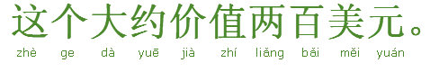
- Security Check
- Any problem with my passport?
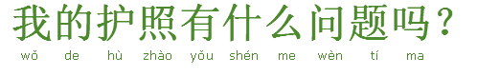
- May I make a call to my consulate?
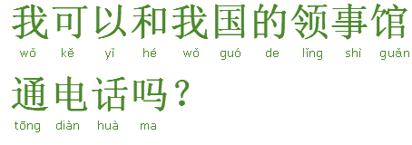

Shopping
- Inquiring
- Do you have formal dresses?
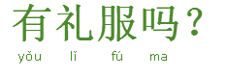
- Do you have suits?
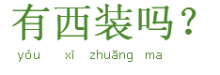
- Do you have ties?
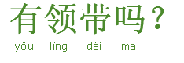
- Do you have a medium-sized one for this t-shirt?
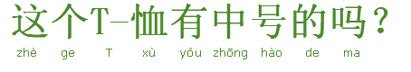
- Do you have a small-sized one for this t-shirt?
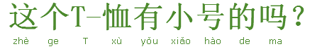
- Do you have a large-sized one for this t-shirt?
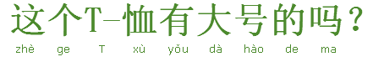
- Do you have any other colors?
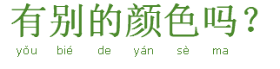
- Do you have any other sizes?
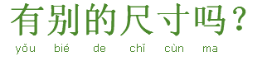
- Do you have any other styles?
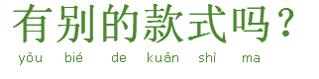
- There is something wrong with the clothes. Could you please change one?
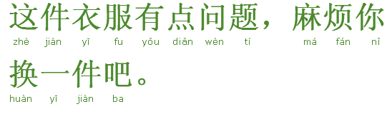
- There is something wrong with the hat. Could you please change one?
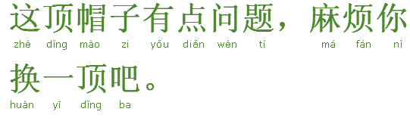
- There is something wrong with the shoes. Could you please change one?
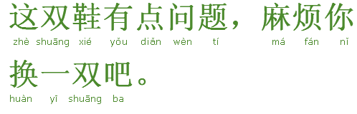
- There is something wrong with the bag. Could you please change one?
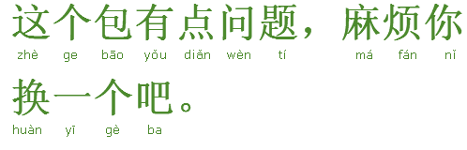
- May I try this on?
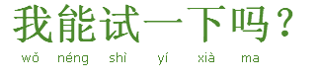
- Bargaining
- It’s too expensive. Can I have it a bit cheaper?
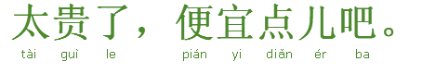
- Can you make it cheaper? I’ll come next time. 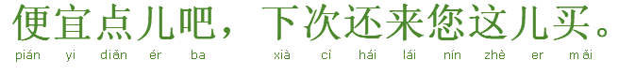

- Can you make it a bit cheaper? I’ll bring more friends here next time.
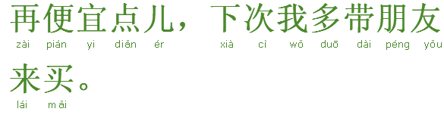
- Can I have it a bit cheaper? You will get small profits but quick returns.
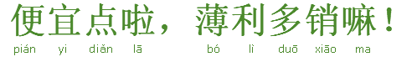
- This is a little expensive.
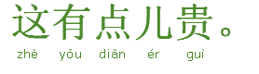
- 20% discount.
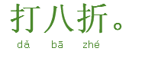

At the Hotel
- Reserving a Room
- I’d like a standard room.
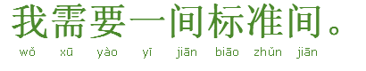
- I'd like a suite.
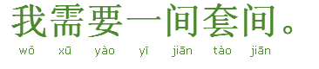
- How much is a single room for one night?
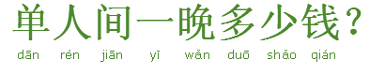
- How much is a double room for one night?
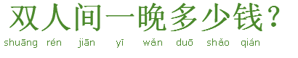
- Do you have any cheaper room?
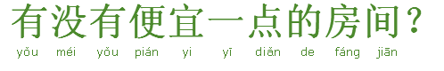
- Do you have any quieter room?
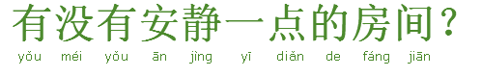
- Do you have any cleaner room?
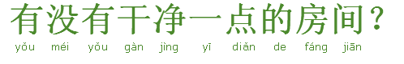
- How much is it per month for a long-term charter?
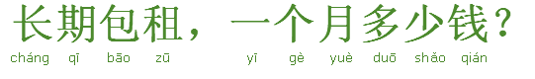
- Could you show me the room first?
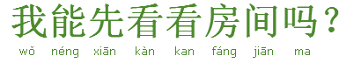
- Could you show me another room?
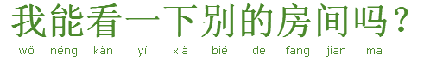
- May I change my room?
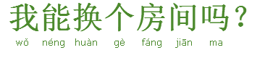
- Can I access the Internet in the hotel room?
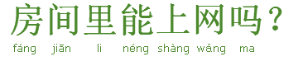
- Can I take showers in the hotel room?
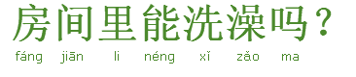
- Can I watch TV in the hotel room?
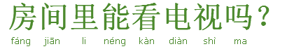
- Is the room equipped with air-conditioner?
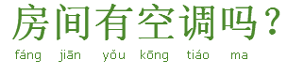
- Is the room equipped with fridge?
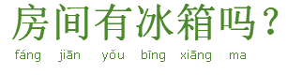
- Is the room equipped with international direct dialing telephone?
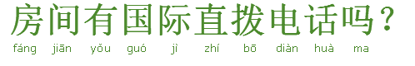
- Is the breakfast included in the room rate?
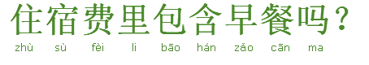
- I’d like a room facing the south with a balcony.
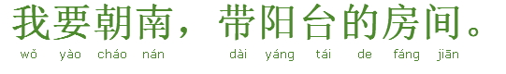
- I’d like to reserve a standard room for next Monday.
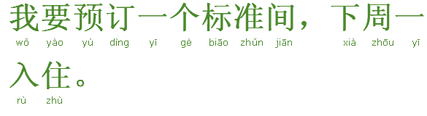
- I will arrive a bit late. Please hold my reservation.
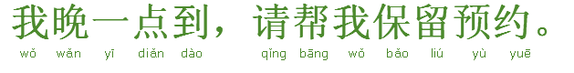
- Check out, please.
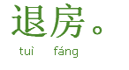
- I’d like to stay one more night, please.
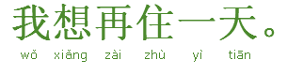
- Hotel Service
- Please clean my room right now.
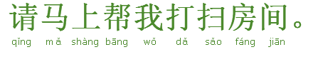
- Please come and clean the room in two hours.
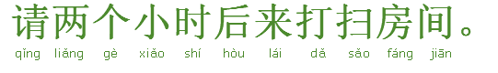
- No disturbance, please.
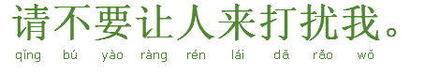
- Could you please change the sheet for me?
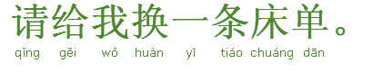
- Could you please change the pillow for me?
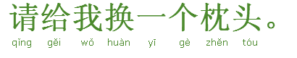
- Could you please change the quilt for me?
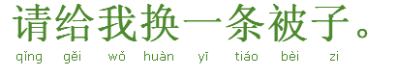
- The air conditioner doesn't work well.
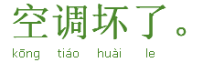
- The shower doesn't work well.
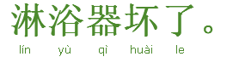
- The toilet doesn't work well.
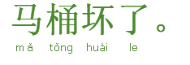
- Please wake me up at 7 o’clock.
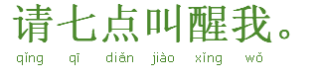
- Could you please call a taxi for me?
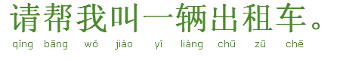
- Can I deposit valuables here?
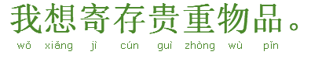
- Can I deposit baggage here?
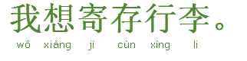
- I’d like my baggage back.
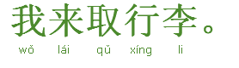
- I’m locked out of my room. I left my key in the room.
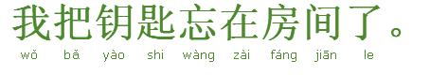

At the Tourist Attraction
- Where can I buy tickets for admission?
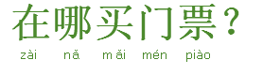
- Where can I buy admission tickets for Huangpu River cruise ship
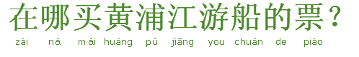
- Do you have any brochure?
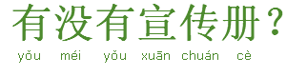
- I'd like to see acrobatics show.
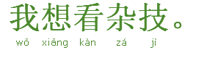
- I'd like to see a movie.
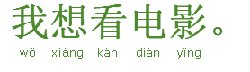
- I'd like to see magic show.
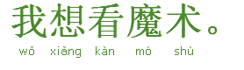
- Can we take a picture here?
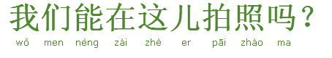
- Excuse me, could you please take a picture for us?
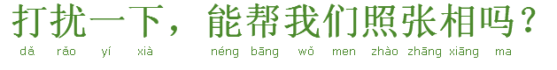
- Can we take a picture together?
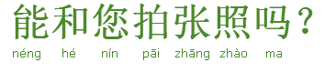
- I’m exhausted.
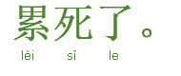
- My legs feel heavy.
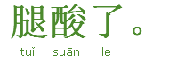
- Let’s have a rest for a while.
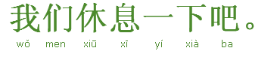
- Where is the nearest exit?
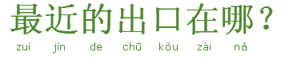
- Where is the nearest entrance?
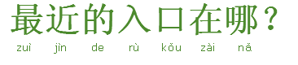
- Where is the nearest bus station?
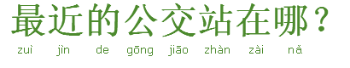
- Where is the nearest subway station?
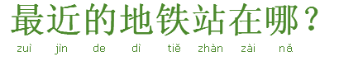

At the Hospital
- I have a fever.
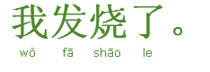
- I have a cold.
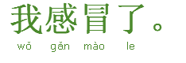
- I have a headache.
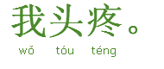
- I have a runny nose.
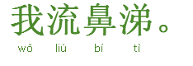
- I have a stomache?.
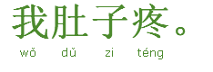
- I have a cough.
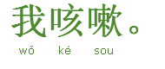
- I have no appetite.
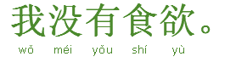
- I fell like vomiting.
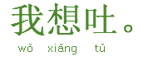

Asking for Directions
- Excuse me, how can I get to the supermarket?
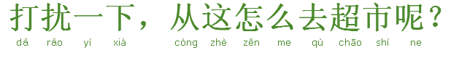
- Excuse me, how can I get to the bank?
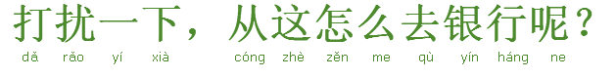
- Excuse me, how can I get to the hospital?
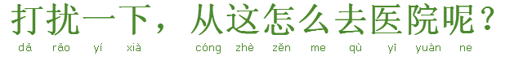
- Is there a restaurant around here?
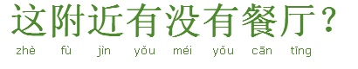
- Is there a cafe around here?
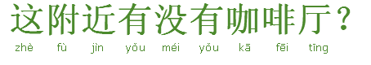
- Is there a tea house around here?
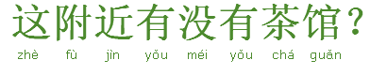
- Where is it on this map?
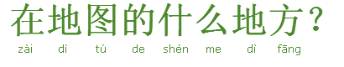
- How long does it take to walk there?
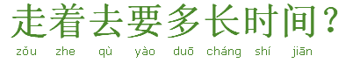
- Can I get there by city bus?
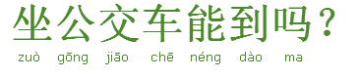
- Can I get there by subway?
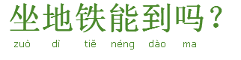
- Walk along this road, turn left at the first cross and you’ll get there.
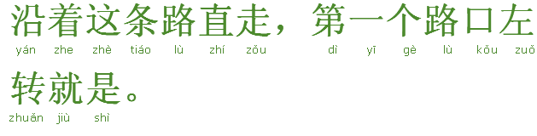
- You can take bus line12 to get there.
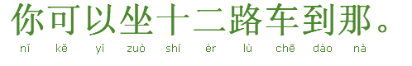
- You can take subway line 2 to get there.
